|  |
| --- |
|  |
| User Manual |
| SWAP (A bartering website) |
|  |
| **M.A.Sajidha** |
|  |

|  |
| --- |
|  |

Contents

1. Introduction 3

2. System Requirements 3

3. System 3

3.1. Home 3

3.2. Home (after user Login or Sign up) 5

3.3. Category 6

3.4. Contact Us 7

3.5. Login 8

3.6. Sign Up 9

3.7. User Profile 10

3.8. Admin Login 12

3.9. Dashboard 13

3.10. Menu bar 14

3.11. Confirm Post 15

3.12. Customers 15

3.13. Settings 16

# Table of Figures

Figure 1/ Header 1 2

Figure 2/ Home page tabs 3

Figure 3/ Footer 1 3

Figure 4/ Header 2 4

Figure 5/ Login details modal 4

Figure 6/ Footer 2 4

Figure 7/ Electronics category 5

Figure 8/ Product details 5

Figure 9/ Contact Us page 6

Figure 10/ Login page 7

Figure 11/ Sign Up page 8

Figure 12/ User profile page 9

Figure 13/ Edit product details modal 10

Figure 14/ Admin login page 11

Figure 15/ Dashboard (Admin panel) 12

Figure 16/ Dashboard menu bar 13

Figure 17/ Confirm post page 14

Figure 18/ Customers page 14

Figure 19/ Settings page 15

# 1. Introduction

SWAP website is an exclusive website designed for Sri Lankans, which acts as a platform for users to post used products which other users can view and make offers to the product owner to exchange products for free of charge. It has an admin panel that is used to manage the website posts added by users as well as to maintain other functionalities. To use the admin panel it important to read the user manual to understand the functionalities of the website.

# 2. System Requirements

* Process - i5 or i7, a quad core processor with atleast 3GHz speed.
* RAM - 4 GB or higher
* Disk Space - Minimum of 300 MB
* Browser - Google Chrome, Apple Safari, Mozilla Firefox. Opera Mini

# 3. System

## 3.1. Home

* The website home page can be accessed using the following link:- [https://swapwebsite.000webhostapp.com/index.php](https://swapwebsite.000webhostapp.com/index.php%20).



6

5

4

32

2

1

Figure / Header 1

* Home page has a menu bar with following buttons,
  + 1 and 2 - When clicked loads "Home" page.
  + 3 - When clicked expands to display the categories.
  + 4 - When clicked loads "Contact us" page.
  + 5 - When clicked loads "Login" page.
  + 6 - Opens login page if user has not logged in yet, if not loads "Post a product" page.

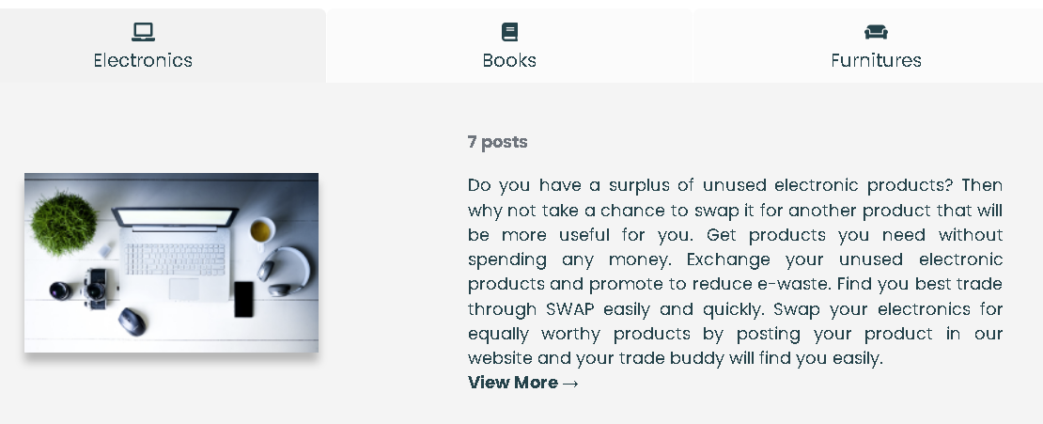

4

3

2

1

Figure / Home page tabs

* Has tabs related to categories offered by the website,
* 1 - Electronics
* 2 - Books
* 3 - Furniture
* 4 - Each of this tab has a button named as "View more" which will load that particular category page when clicked.

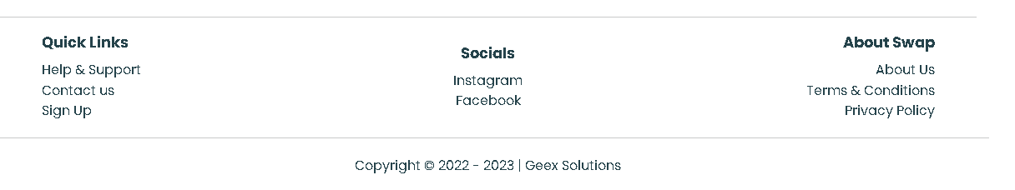

8

7

6

5

4

3

2

1

Figure / Footer 1

* Footer has 'quick links', 'socials' and 'about SWAP'. Each of this section has link, when clicked will lead to that particular pages.
* 1 - This page describes how to use the SWAP website properly.
* 2 - This page allows any users to contact SWAP.
* 3 - This page allows unregistered users to Sign up.
* 4 - Opens up SWAP Instagram page.
* 5 - Opens up SWAP Facebook page.
* 6 - This page has all the information about SWAP.
* 7 - This page clearly describes the terms and conditions users should abide and follow when using SWAP website.
* 8 - This page describes the privacy policies maintained by SWAP website.

## 3.2. Home (after user Login or Sign up)

* Menu bar options will change, where "Login" button will be replaced with "My Account" button.



Figure / Header 2

* User can view their login details by clicking on "My Account" button.

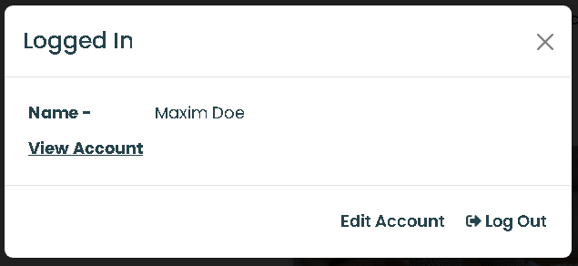

Figure / Login details modal

* When "View Account" and "Edit Account" buttons are clicked, it will lead the user to "User Profile" page.
* If "Log Out" option is clicked, user will be logged out of their account and returned to "Login" page.
* Footer will also be changed, where no sign up link will not be available as the user has already signed up.

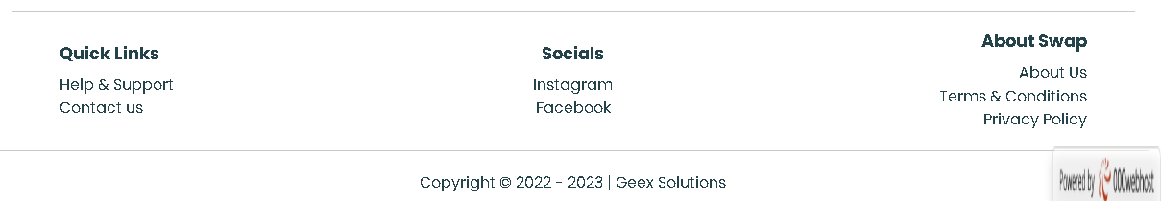

Figure / Footer 2

## 3.3. Category

* Display products posted by users.

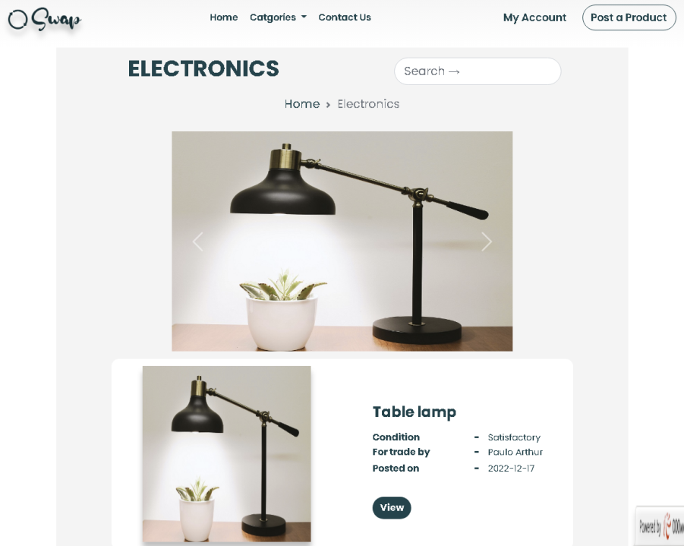

Figure / Electronics category

* A product is display in category page only after the admin has confirmed it after verification.
* Each product detail and it's owner details can be viewed using "View" button on each post.

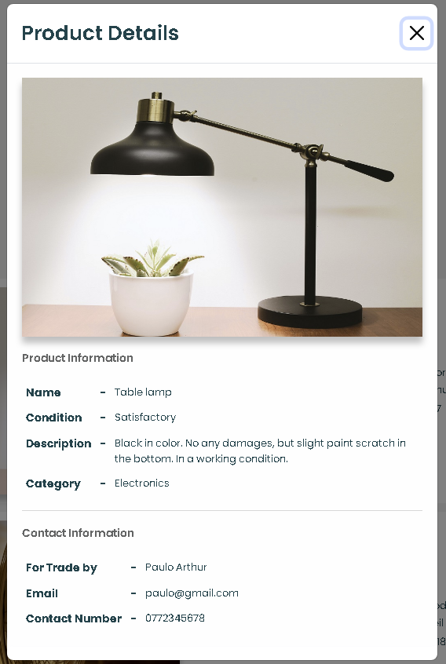

Figure / Product details

## 3.4. Contact Us

* Has the contact form which can be used by the user (both registered and unregistered) to send messages regarding any concerns, feedback or complaints directly to SWAP.

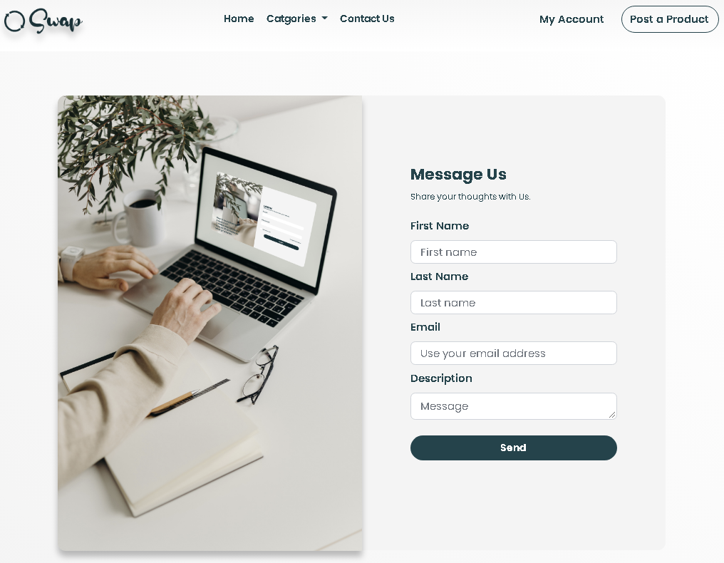

Figure / Contact Us page

## 3.5. Login

* Has the login form which the registered users can use to login to their account.

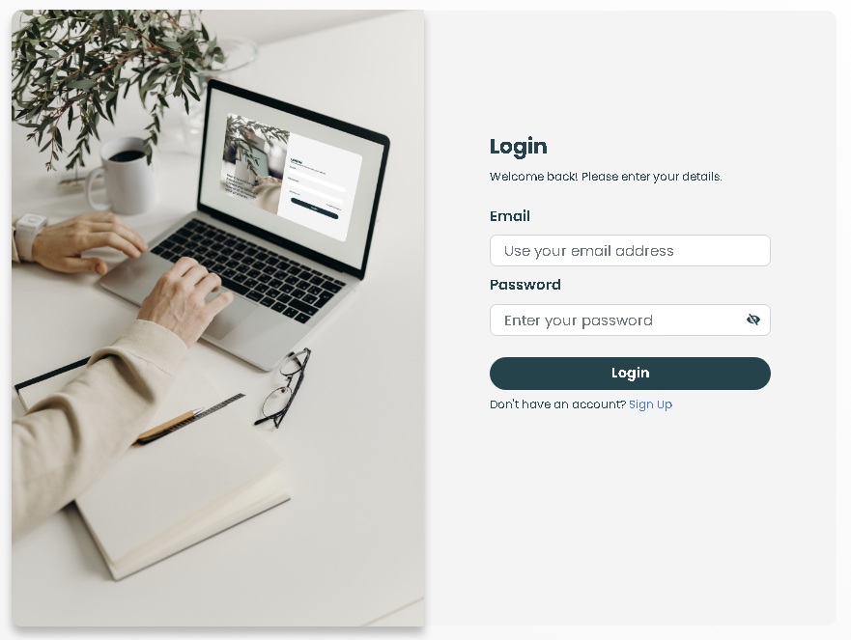

1

Figure / Login page

* 1 - Has a link to "Sign Up" page.
* When the login is successful, user will be lead to "Home" page of the website.

## 3.6. Sign Up

* Has the sign up form which can be used by the new users to get registered.

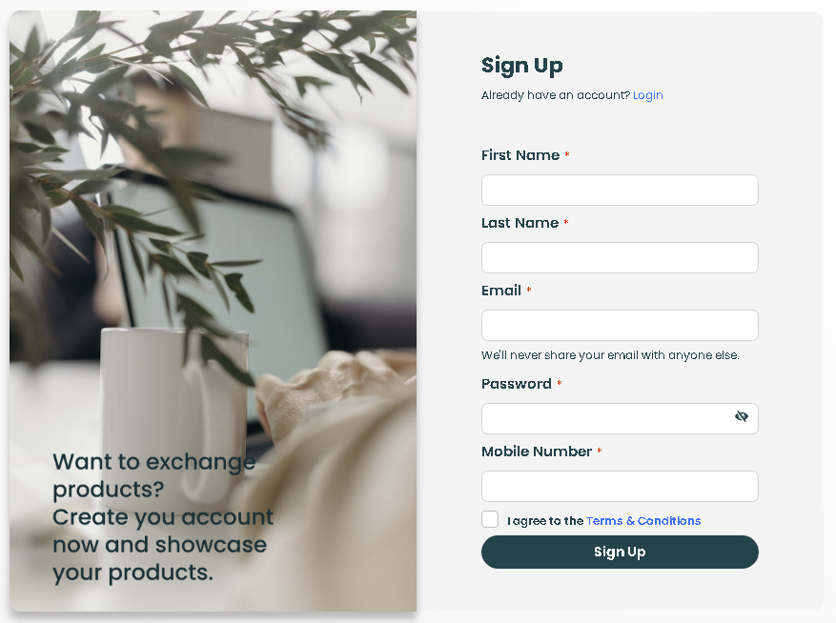

2

1

Figure / Sign Up page

* Once all the details are enter, it is important to agree to "Terms and Conditions" to complete the sign up process.
* 1 - A link to "Terms and Conditions".
* 2 - "Login".
* If the sign up is successful, user is lead to "Home" page.

## 3.7. User Profile

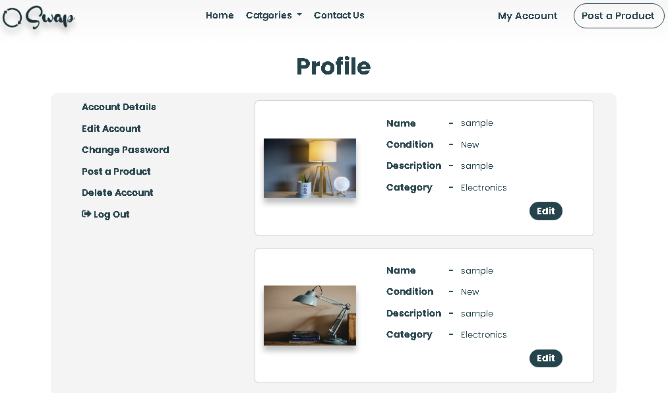

7

6

5

4

3

2

1

Figure / User profile page

1. Has many options such as,

* 1 - When clicked will display all the account details of the user.
* 2 - When clicked will display current account details of the user which can be edited and saved.
* 3 - When clicked will allow the user to change their current password and save.
* 4 - When clicked will load "Post a Product" page in which user can post a product.
* 5 - When clicked will allow the user to delete their entire account. If deleting account is successful, user will be returned to "Home" page.
* 6 - When clicked user will be logged out of their account and will be returned to "Login" page.
* 7 - Allows to edit product details.

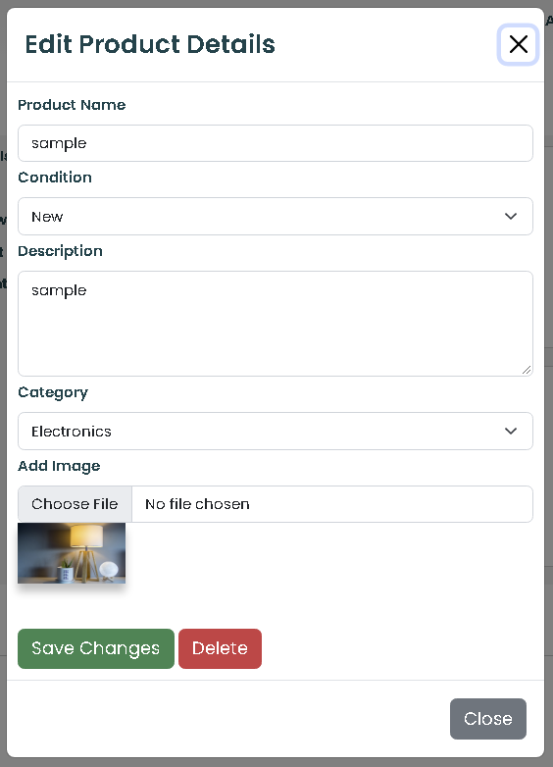

1

2

Figure / Edit product details modal

* 1 - After editing the details, it can be saved.
* 2 - Will delete the product post and cannot be retrieved.

## 3.8. Admin Login

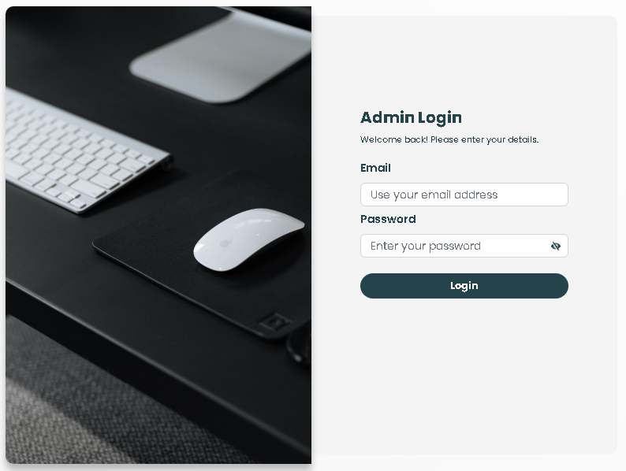

Figure / Admin login page

1. Admin login page can be accessed using the following link:- <https://swapwebsite.000webhostapp.com/admin-login.php>
2. Admin login credentials:- Email (admin@admin.com) and password (admin@123).

## 3.9. Dashboard

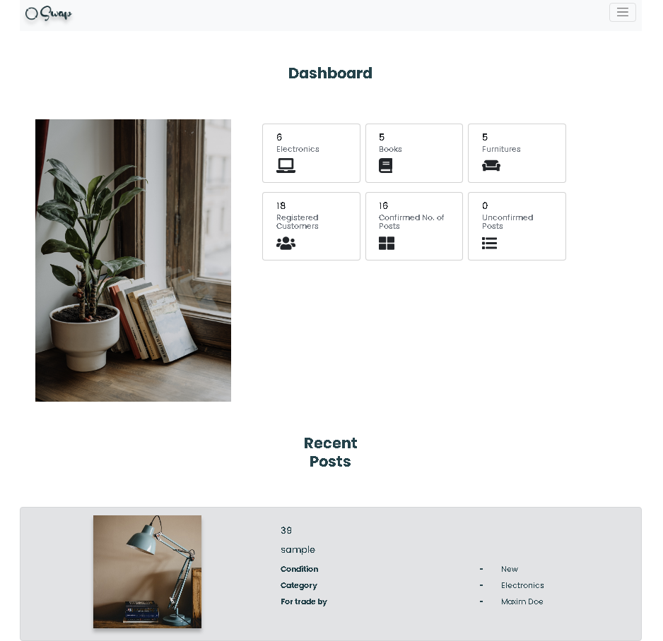

Figure / Dashboard (Admin panel)

* Has the overview details of the website.

## 3.10. Menu bar

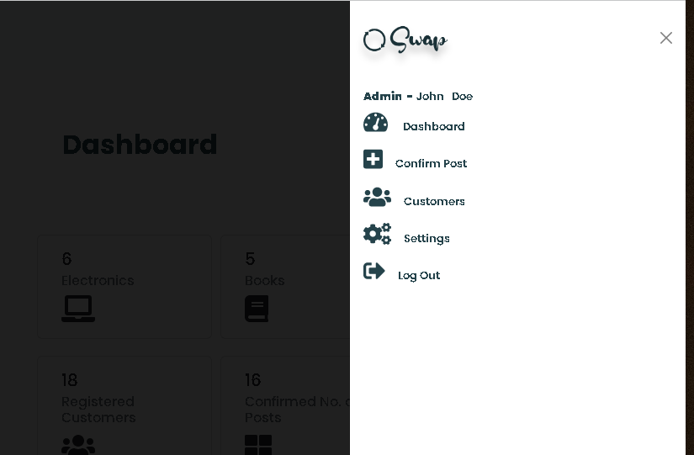

6

5

4

3

2

1

Figure / Dashboard menu bar

* 1 - Shows admin name.
* 2 - Opens dashboard.
* 3 - Opens Confirm post page.
* 4 - Opens Customers page with customer details.
* 5 - Opens settings for admin.
* 6 - Logs out the admin from dashboard.

## 3.11. Confirm Post

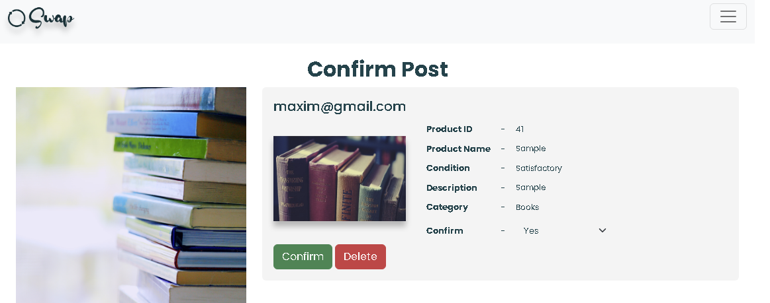

1

2

Figure / Confirm post page

* Displays all the posts newly added or updated by the users.
* 1 - Confirms the post and displays in relevant category page.
* 2 - Will delete the post and cannot be retrieved.

## 3.12. Customers

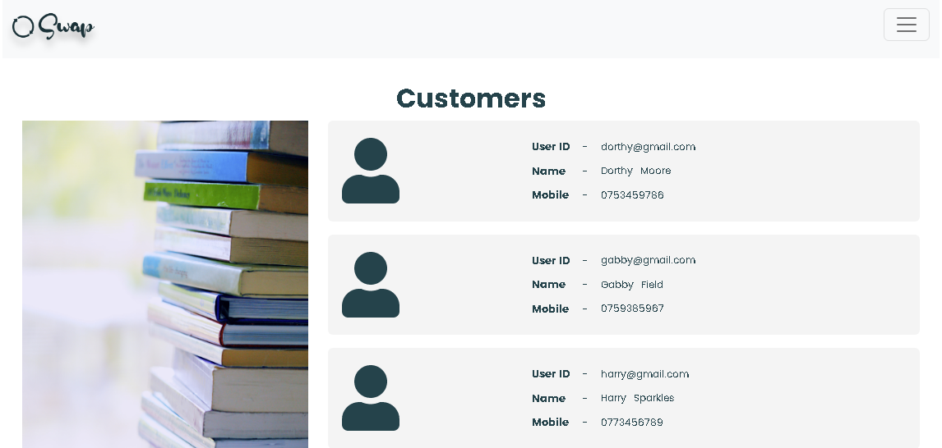

Figure / Customers page

* Displays all the registered customer details.

## 3.13. Settings

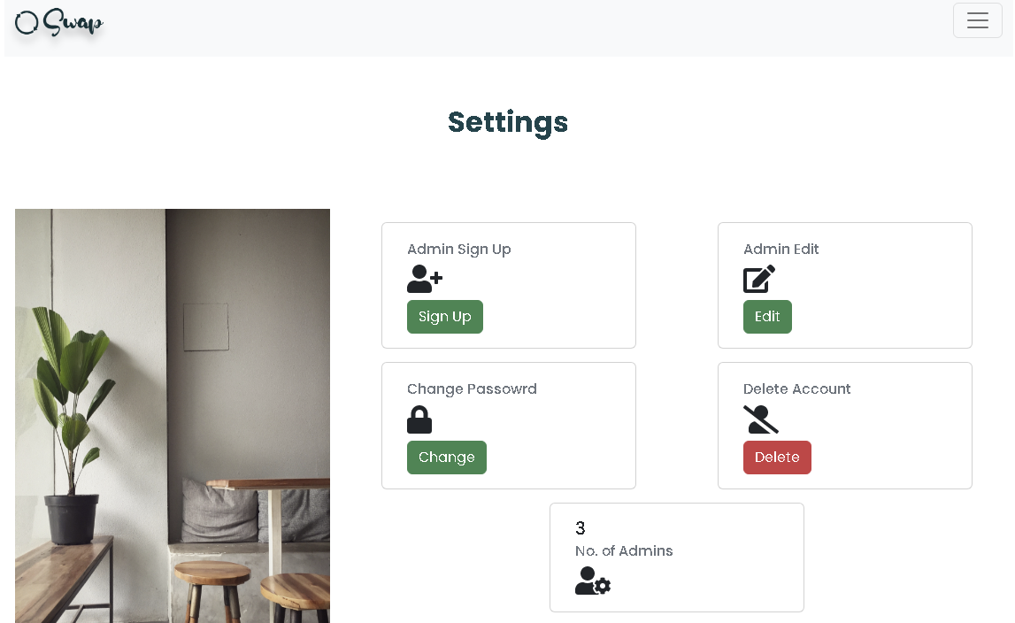

3

1

4

2

Figure / Settings page

* 1 - Allows new admin to sign up.
* 2 - Allows logged in admin to edit their account details.
* 3 - Allows logged in admin to change password.
* 4 - Allows logged in admin to delete their account.